Eyes
- Stimulus vs. sensation
- Receptors
- Phantom limb effect
- Conjuctiva (label and function)
  - Conjuctivitis
  - Goblet cell
- Accessory structures
  - Eyebrow- label and function
  - Eyelash- label and function
  - Eyelids- label and function
- Eye structures
  - Vitreous chamber
    - What does it contain?
    - Label
  - 3 layers of eye wall
    - Fibrous tunic
      - Cornea – function and label
      - Sclera- function and label
    - Vascular tunic (label all)
      - Choroid
      - Ciliary body
      - Iris
    - Retina- what is its function?
      - Cones - function
      - Rods- function
      - Fovea centralis- importance?
  - Lens
    - Function
    - Label
    - How does it bend in accordance for near objects versus far?
    - What is it made of?
- Myopia, presbyopia, emmetropia (normal vision), hyperopia
- Know the image below!
- 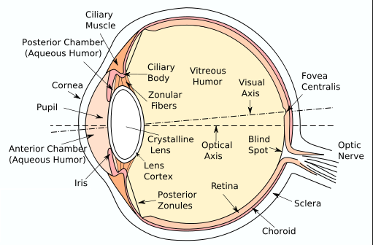
- Hearing
  - Inner, middle, external ear (label)
  - Function of tympanic membrane
  - Function of acoustic meatus and be able to label
  - Be able to label all parts mentioned in class
  - What is function of auricle?
  - What is function of Eustachian tube?
  - What is function of Organ of Corti?
  - What is function of the ossicles?
  - What is function of cochlea
  - What is the importance of the tympanic reflex? How does it work (brief description)
- Taste
  - What is its scientific name?
  - Distinguish between the types of the papillae and where you might find them.
  - Which papillae is the largest and contains the most taste buds?
  - Importance of saliva
  - Structure of a taste bud
  - Why does our ability to taste decrease as we age?
  - What are the taste sensations and what causes them?
- Touch
  - Meissner’s corpuscles- what do they detect?
  - Pacinian corpuscles- what do they detect?
  - Free nerve endings
  - The three receptors: touch, pain, temperature
  - Temperature ranges for temperature receptors- what happens when the temperature is above or below?
  - Why do you not feel cold after being in a pool/lake for a while (this applies to temperature sensors in general)
  - Pain sensors
    - What kinds?
    - Low adaptation
    - Any in brain?\
    - \
- Olfaction/smelling
  - Chemoreceptors
    - Why do they need saliva
      - This is why taste and smell go hand-in-hand
  - Olfactory organs- what two types of cells?
  - What is the structure of the olfactory cells that helps them detect chemicals?
  - Smell is sent to the limbic system- emotions linked to smells
  - Adaptation in olfactory smells- don’t notice smells after a while.

