Skeletal System
Name: ____________
- Label the bone
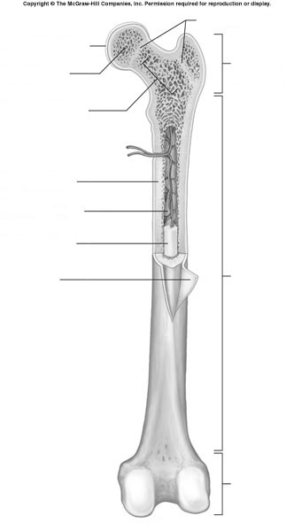

- What is meant by distal vs. proximal epiphysis?

- What is an Osteocyte? What is an Osteon?

- What is the difference between a central canal vs. a Volkmann’s canal?

- What does articulate mean in the context of a bone?

- What are 5 functions of a bone?

- What are the four classes of bones in terms of shape? Into which group would the os coxae (hip bone) be placed?

