Body Cavity Interactive

Go to: https://www.wisc-online.com/learn/natural-science/life-science/ap15505/the-organization-of-the-human-body--body-cavities

What comprises the axial region?

What is part of the appendicular region?

What are the two major body cavities?

The organs within a cavity are known as __________________ (see chapter 1 under body cavities).

Label the dorsal and ventral cavities on the image below:
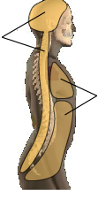
The dorsal cavity consists of two different cavities, the _________ and __________ cavities.

What organ is contained in the cranial cavity? _______________.

Does anything separate the cranial cavity from the spinal/vertebral cavity? If so, what does?

The ventral cavity is separated into two regions by the _______________.

Label the below diagram:

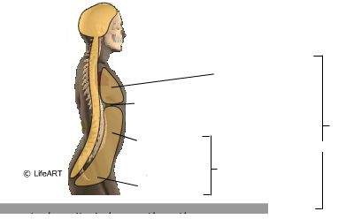

Superior (above) the diaphragm is the ______________ cavity. Below it, is the _______________ cavity.

What can be found in the thoracic cavity?

What is found in the mediastinum?

What cavities contain the lungs?

Please label the following image

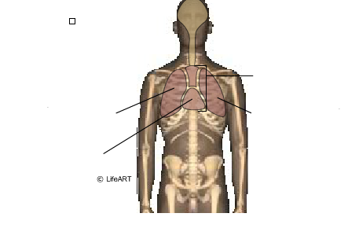

The ________________ cavity is inferior/below the diaphragm.

The abdominopelvic cavity is divided into two portions the _______________ and _________________.

What is an example found in each of the two regions of the abdominopelvic cavity?

What is the dorsal cavity protected by?

What is the ventral cavity protected by? (Provide both terms)

What is the difference between parietal serosa and visceral serosa? Find an image that shows the two labeled clearly (can be different website) and draw it in the space below after answering the first question.

What is found between the parietal and visceral membranes?

The serous membranes have a specific name for the pleural cavities. What are they?

Serosae of the heart are called ___________________. What might help you remember that (Hint: think about the name)

Serosae of the abdominopelvic cavity are called __________________________. What is the plural term for these? ____________________. (HINT: see textbook chapter)

